**Client Side code:-**

package com.mycompany.tcpclient;

import java.io.BufferedReader;

import java.io.DataInputStream;

import java.io.DataOutputStream;

import java.io.FileReader;

import java.net.Socket;

import java.util.Scanner;

public class UDpClient {

public static void main(String arg[]) throws Exception {

System.out.println("Attempting to connect...");

Socket socket=new Socket("localhost",5000);

DataInputStream readInput = new DataInputStream(socket.getInputStream());

DataOutputStream writeOutput = new DataOutputStream(socket.getOutputStream());

Scanner ip=new Scanner(System.in);

System.out.println("Start transfering");

String transfer="";

// read file

BufferedReader reader;

try {

reader = new BufferedReader(new FileReader("C:\\Users\\MUBASHIR KHAN\\Desktop\\UDP.txt"));

String line = reader.readLine();

while (line != null) {

transfer=transfer+line+"\n";

line = reader.readLine();

}

reader.close();

} catch (Exception e) {

e.printStackTrace();

}

//write to stream output

writeOutput.writeUTF(transfer);

System.out.println("Transfer done!\nClosing connection");

// close connection

socket.close();

readInput.close();

writeOutput.close();

ip.close();

}

}

**Server Side code :-**

package com.mycompany.tcpserver;

import java.io.DataInputStream;

import java.io.DataOutputStream;

import java.io.FileWriter;

import java.net.ServerSocket;

import java.net.Socket;

import java.util.Scanner;

public class UdpServer {

public static void main(String[] args) throws Exception{

// TODO Auto-generated method stub

ServerSocket server=new ServerSocket(5000);

System.out.println("Server started");

System.out.println("Waiting for a client ...");

Socket socket = server.accept();

System.out.println("Client has joined sharing ");

DataInputStream readInput = new DataInputStream(socket.getInputStream());

DataOutputStream writeOutput = new DataOutputStream(socket.getOutputStream());

Scanner ip = new Scanner(System.in);

// get Stream socket input

String lines=readInput.readUTF();

//write to files

FileWriter myWriter = new FileWriter("C:\\Users\\MUBASHIR KHAN\\Desktop\\UDP.txt");

myWriter.write(lines);

myWriter.close();

server.close();

socket.close();

writeOutput.close();

readInput.close();

ip.close();

}

}

Client side output :-

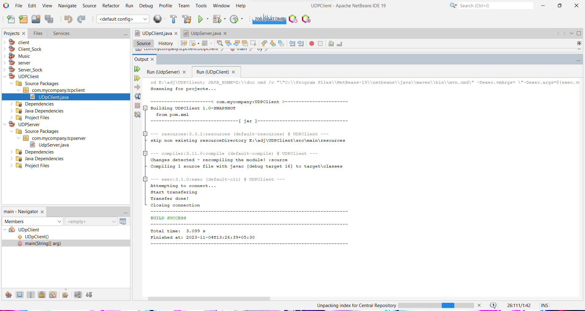

Server side output:-

